**[ Beginner & Low Kyu Guidance (1) ]**

As mentioned before, Beginner and Low Kyu refer to players who are:

**Beginner – below 15 kyu**

**Low Kyu – 6~14 kyu**

Generally those are players who just started in Go, and who are quite likely to make much progress within days. **Beginners** may still have a hard time with the rules of this game, and it sometimes happens they don’t know when a game ends. As for **Low Kyu** players, they could beat beginners easily but got crushed by players who are just a little stronger than them, and might face constant losses. Therefore, the strategy that applies to those two groups are different.

In my opinion the **keywords** and **suggestions** for those two groups are:

|  |  |  |
| --- | --- | --- |
|  | **Keywords** | **Suggestions** |
| **Beginner** | Rules  Liberty & Shape | OGS Bot Games  Play on 9x9  Kill stones |
| **Low Kyu** | Skill Training  Territory & Efficiency | Play on bigger boards  Traditional Openings  Tsumego Training  Play slow games online |

**Tips for Beginners**

Perhaps you have just decided to learn about this game after the news of AlphaGo, or maybe you simply want a glimpse of this mysterious game because the AI project you’re currently working on requires some background knowledge. You might also be a kid who is curious about the game --- Whoever you are, you’ve come to the right place. Here are tutorials about how to go through the very first stage of **Beginner.**

**Keyword 1: Rules**

Go is a game, and a game has rules. Therefore, the very first thing a beginner should do is to remember the rules. Unfortunately, the rules of Go is a bit complicated, which scares away beginners. My job here is to brief you on the most important rules so that you can finish a game properly; and if you want more information on Go rules, just turn to Wikipedia.

The explanations of Go terms are available at Sensei’s library: <https://senseis.xmp.net/> .

The formal Go rules can be divided into three parts: before game, during game and after game.

**1.1 Before Game – Nigiri & Bow & Time Setting**

The term *Nigiri* refers to the process to decide which player should play as black. Normally it’s done by guessing the stones. Here are the steps:

(1) One player (usually the elder one, or the one with the white stones) grabs some stones out of the white box, and holds them.

(2) The other player needs to make a guess about whether the total number of the stones is odd or even. If your guess is odd, just put one black stone on the board. If your guess is even, put two black stones on the board.

(3) The first player puts all the white stones on the board and see if the guess is correct.

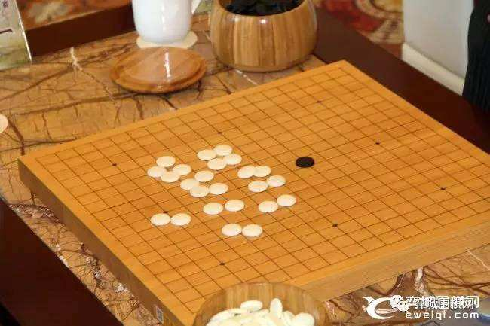

**Figure 1.** *Nigiri* – guessing the stones. On this board the guess is odd but the total is even, so the elder one plays as black, or can choose the side to play as.

Usually, if your guess is correct, you play as black, or you play as white. But there are also tournaments where a correct guess grants you the right to pick whichever side you’d like to play. Such rules of tournaments should be announced before the game starts; and players should pay attention to them.

In an online game, normally the Nigiri part is done by programs. You just need to click “Automatic” as the color you will play as. You can also decide your color. You also need a proper **time setting** that is acceptable by both players. A game invitation needs to be confirmed by two opponents to start.

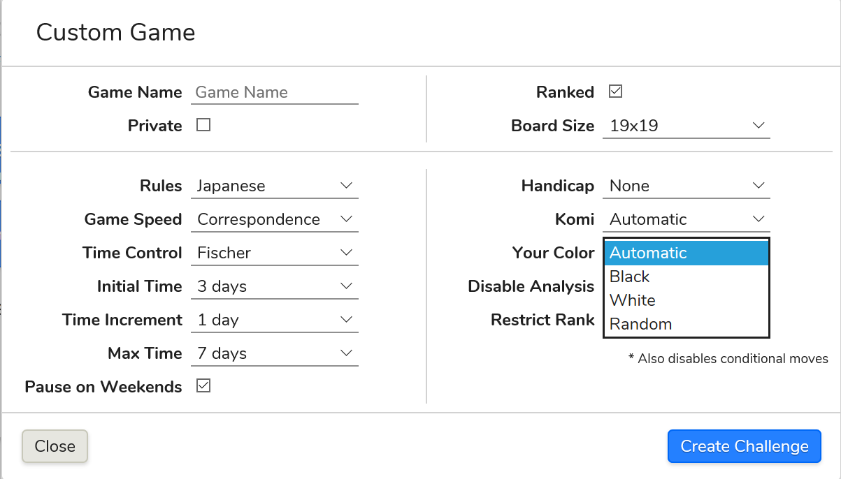

**Figure 2.** Game invitation online. Here we choose OGS as an example. On the left are rules and **time settings**; and on the right you can choose your color as Automatic, Black, White or Random. Automatic and Random all initiate the Nigiri process.

Black gets to play the first move, and usually is the boss of early game. So to make the game fair, black has to make up to white at the end of the game, and the compensation is called *komi*. We will discuss about *komi* later in After Game.

After *Nigiri*, the game is ready to start. But before it starts, please remember that it is normal etiquette to **take a bow** towards your opponent, to be polite. Keep in mind that the result of games does not matter; what matters is good manners.

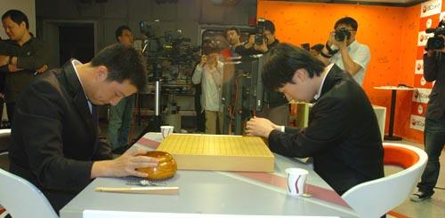

**Figure 3.** Take A Bow Before Game Starts.

**1.2 In Game – *Liberty* & *Ko* situation & when to end a game**

*Ko* is the most complicated situation in this game, but it is easy to explain. All rules – Chinese & Japanese & Korean or any rule in the world – ban the situation when the same board appears again in one game. Let’s take a look at this 9x9 board.

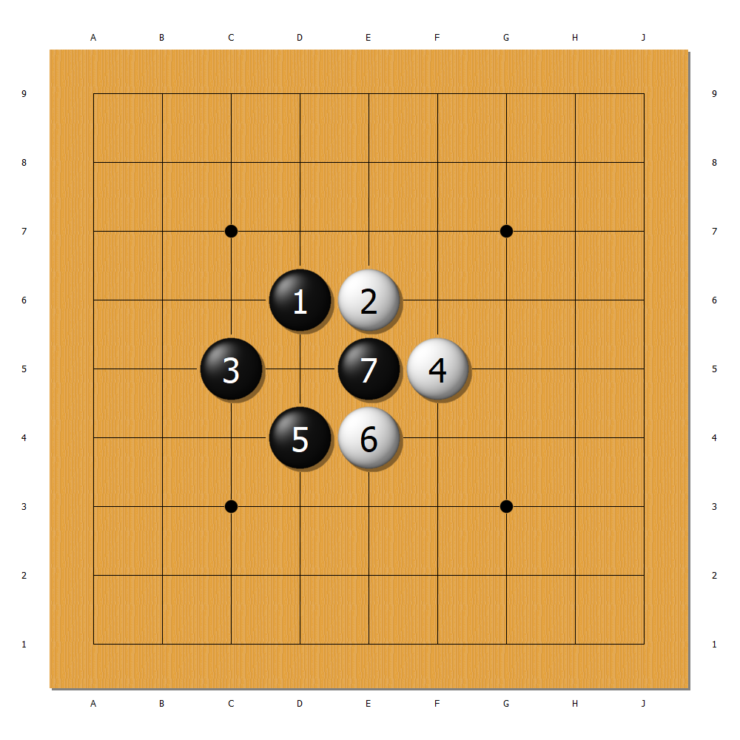

**Figure 4.** A *Ko* Situation. The number on the stones refers to the order in which moves are made, and this is a universal way to keep game records.

Now the black stone 7 has only one *liberty* and can be removed by white with one move at D5. (As liberty decides whether a stone can survive and is especially essential to beginners, it is illustrated in Keyword 2. If you have no idea what *liberty* means, please refer to that part before going on.)

So white now makes the D5 move and removes that black stone:

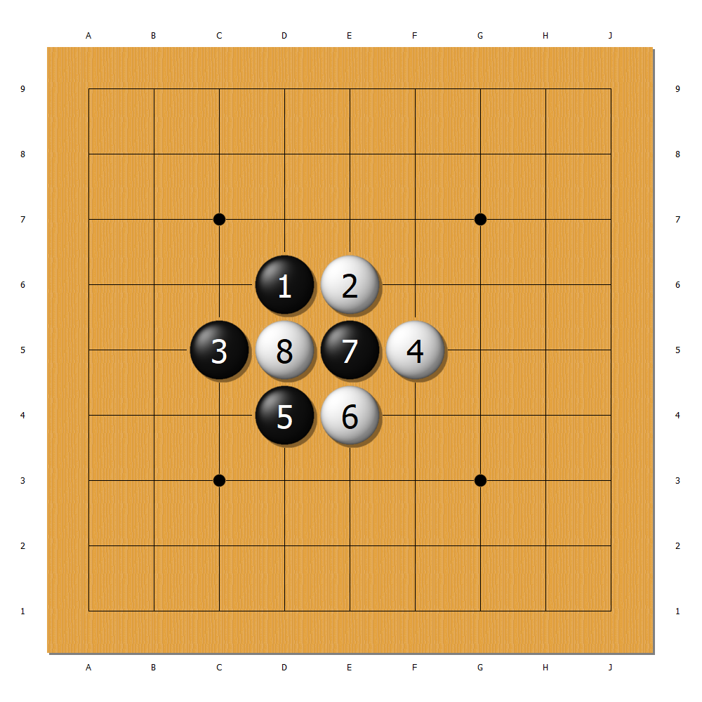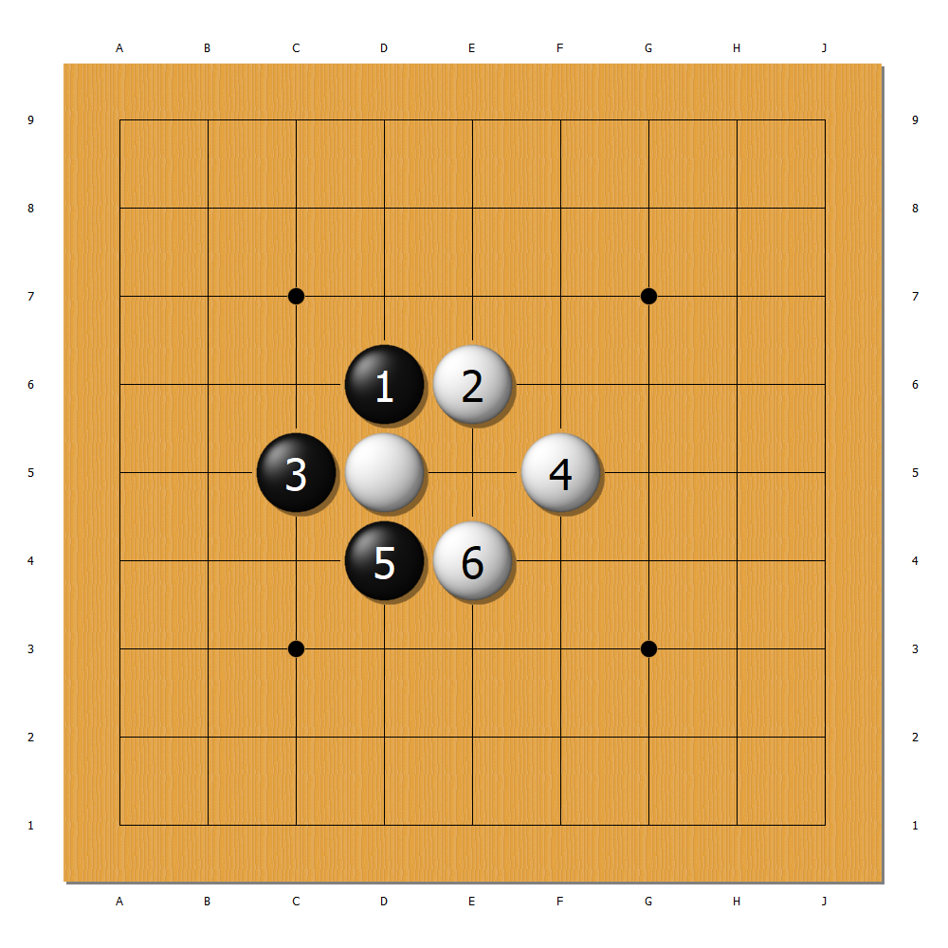

**Figure 5.** White removes the stone.

Now the new move 8 is also at risk: just like the previous move 7, it also has only one liberty and can be removed. But what happens if black makes the E5 move right away?

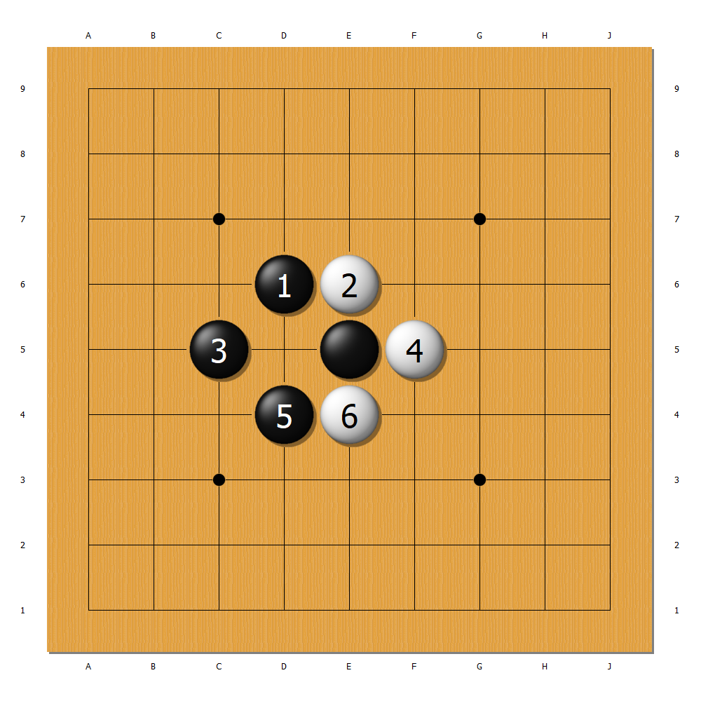

**Figure 6.** Comparison between the original board (left) and the board after black makes the E5 move (right).

It is apparent that the two boards are exactly the same, and this contradicts with the rules of Go. Therefore the black move 9 is forbidden. But it doesn’t mean that white move 8 is immortal! To capture it black must make a move elsewhere and hope for white to respond to it. This move is called a *ko threat*.

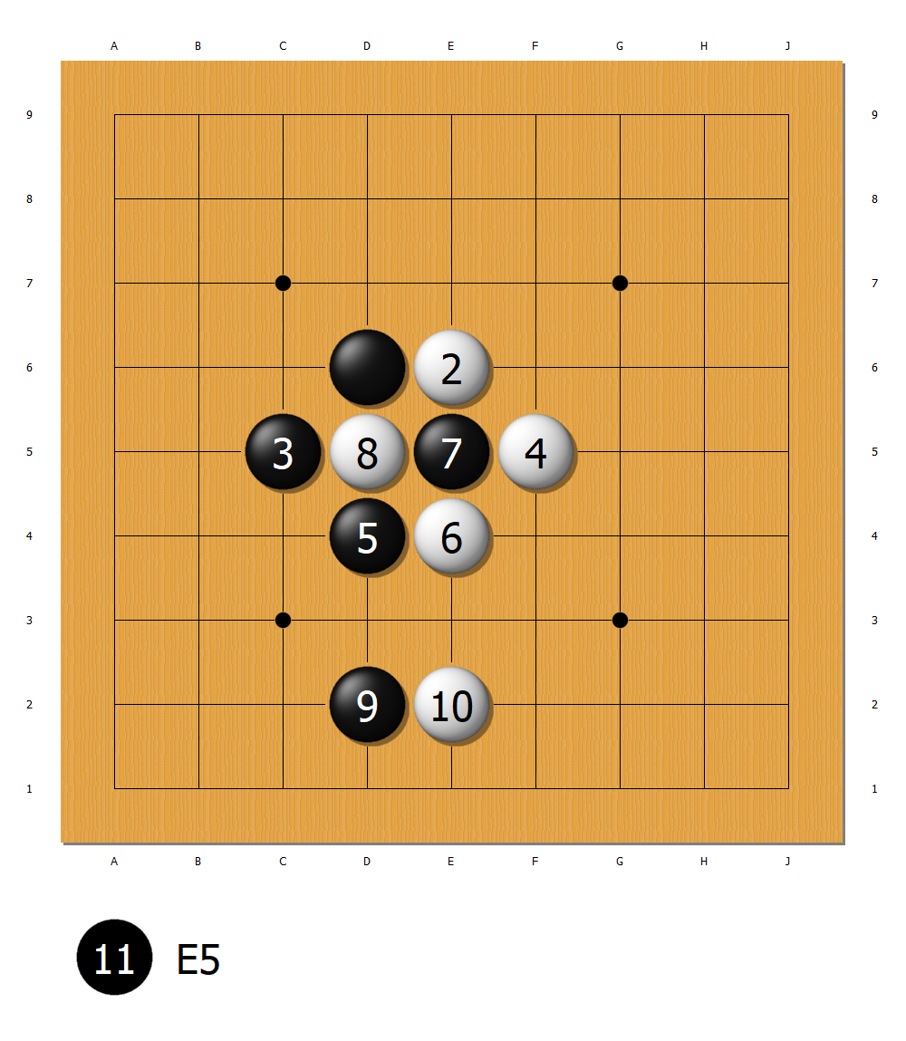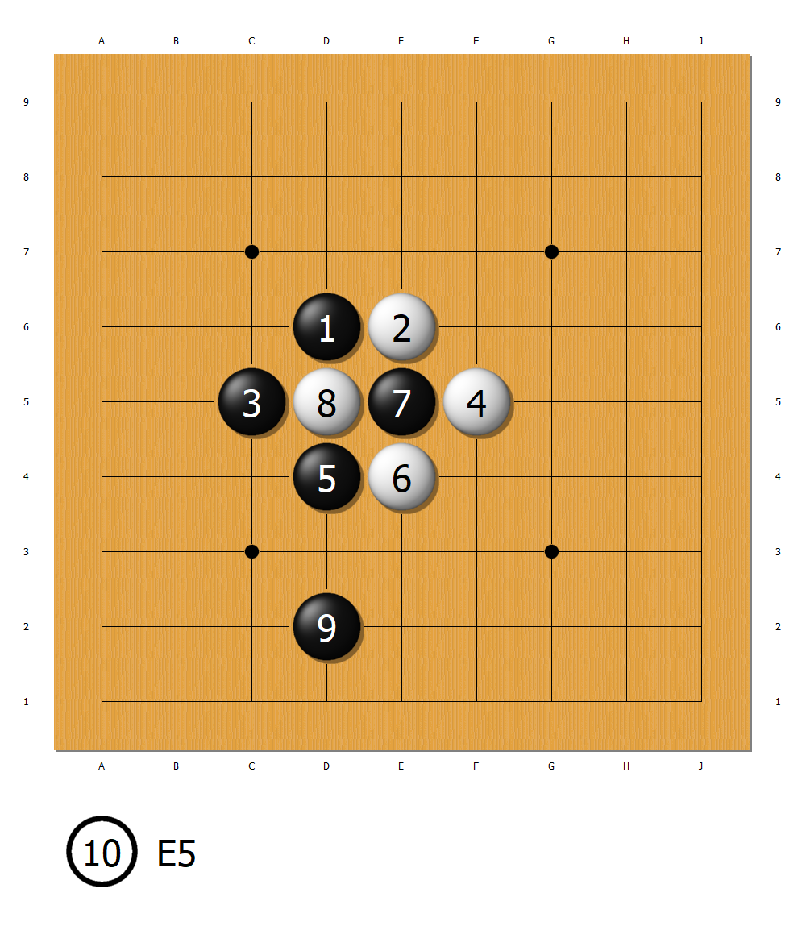

**Figure 6.**  Black makes a move elsewhere, white responds, and black takes the stone back without making the same board appear (left). Or white ignores the black move 9 and connects the stone, which ends the *ko* (right). Black move 9 is called a ***ko threat***, and it has to be valuable enough for white to respond to. **The side with more *ko threats* wins the *ko***, so when you start a *ko*, **always count *ko threats***.

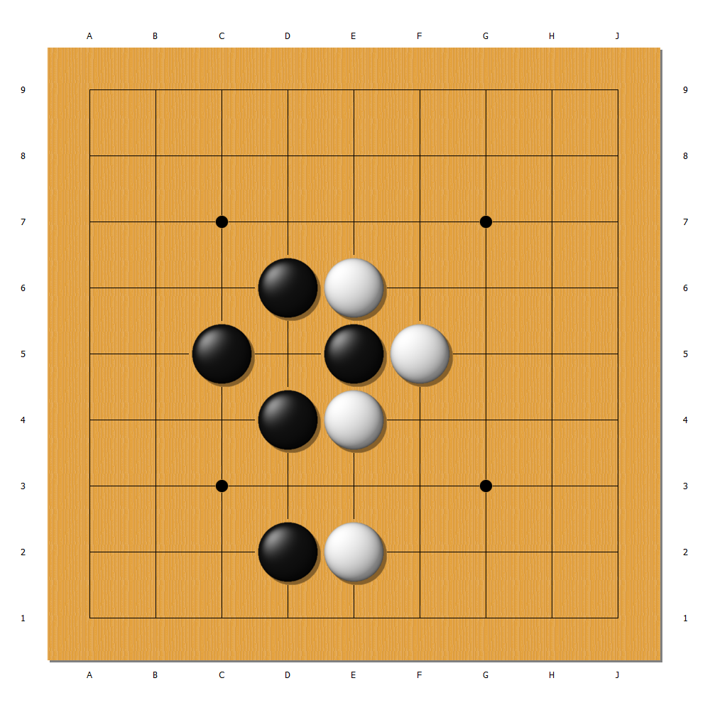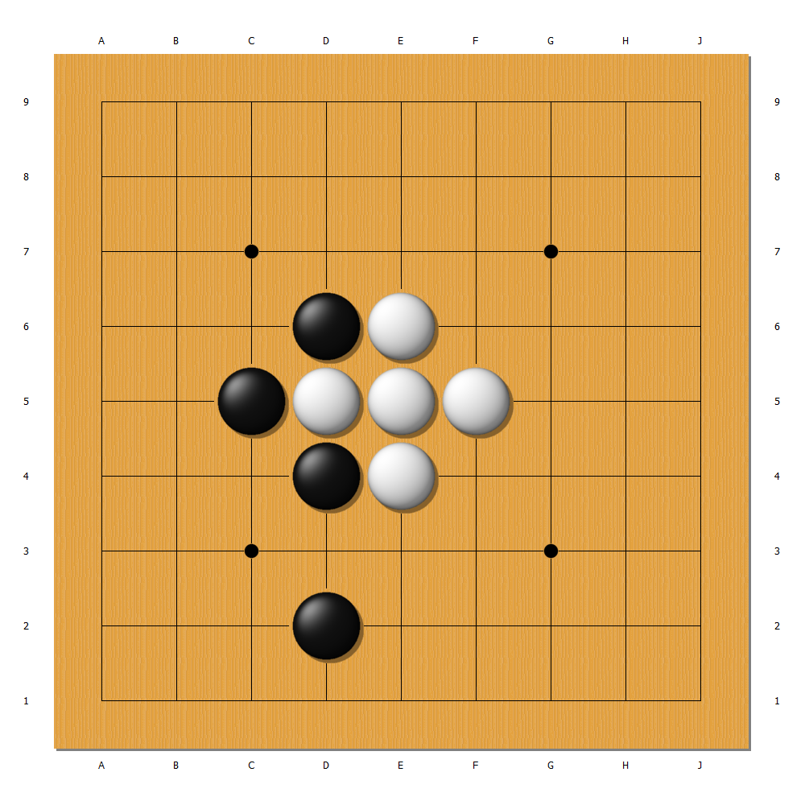

**Figure 7.**  The two final boards of Figure 6.

Another concept beginners must pay attention is **when to end a game**. If you mess with this, either you’ll leave valuable moves on board for your opponent to make, or you’ll find yourself dropping dead stones in your opponent’s territory, which is considered rude behavior unless you have no idea of the Go rules.

**When to end a game depends on the rules you use.** The difference between Chinese rules and Japanese rules (or Korean rules, which is normally the same as Japanese rules) is that **neutral points** matter in Chinese rules, but do not matter in Japanese & Korean rules. So to end a game under Chinese rules you have to play until all neutral points are occupied (which means all the 361 intersections are either black or white), but under Japanese & Korean rules you can leave the neutral points (which means the intersections belong to black/white or are neutral points which are of no value)

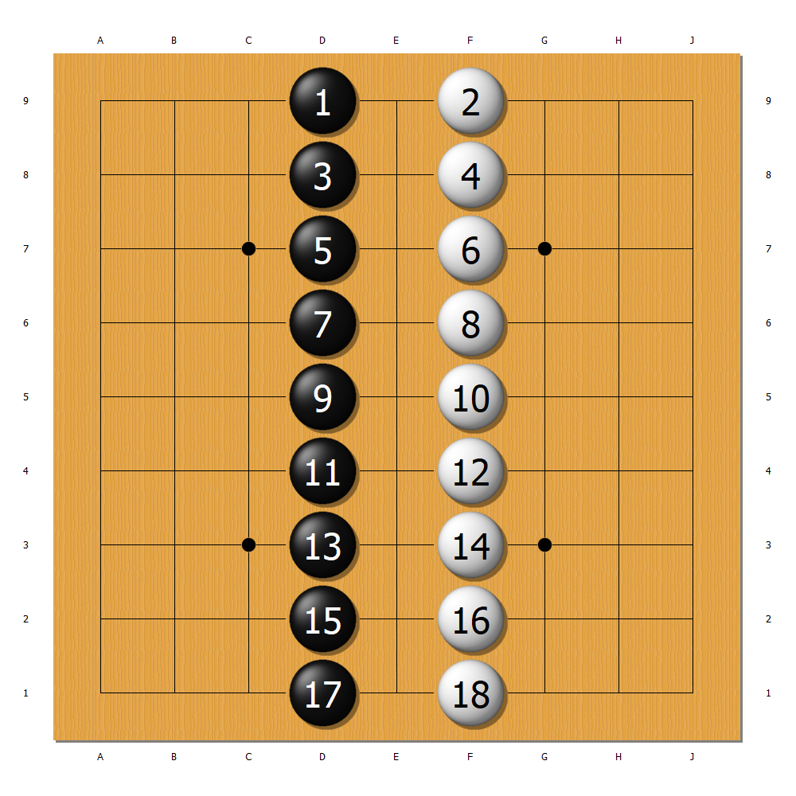 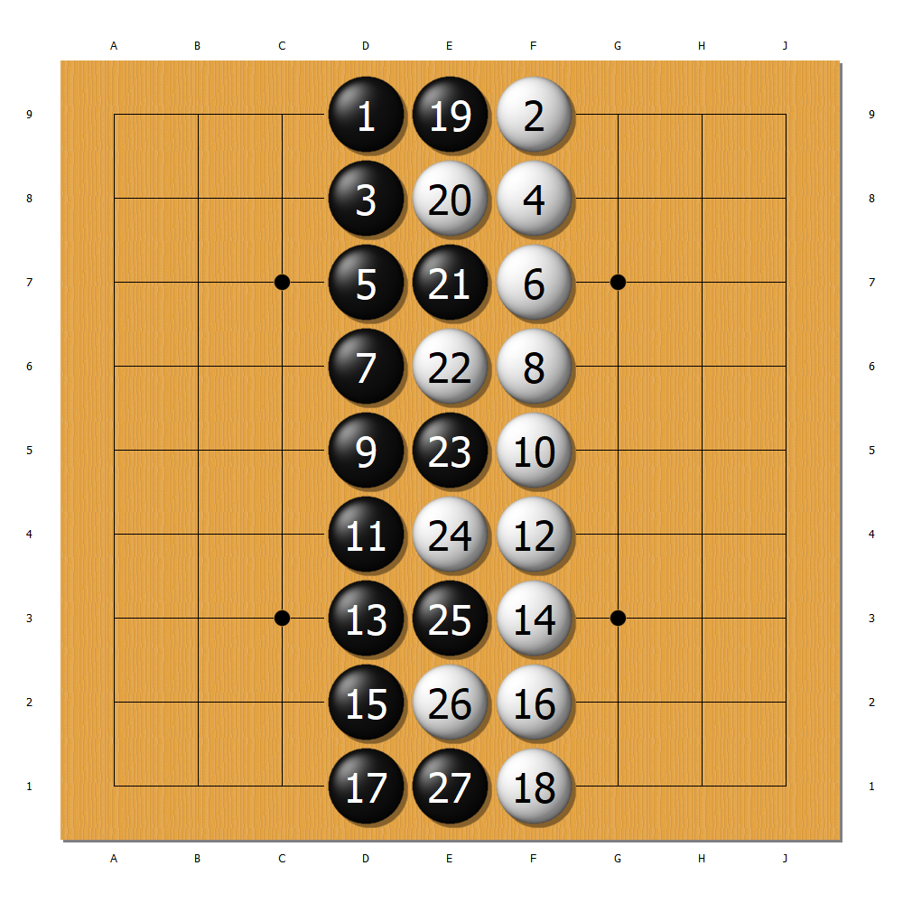

**Figure 8.**  The end-game state under Japanese & Korean rules (left) and under Chinese rules (right). The difference is the neutral points.

**1.3 After Game – *Score counting rules***

After a game is finished, except when one person resigns, it is score counting that determines which side wins. The way to count score differs with rules, so it is extremely important to decide the rules you apply to the game BEFORE the game starts.

In Chinese rules, the neutral points matter, and all neutral points must be occupied before the game ends. In Japanese & Korean rules, the neutral points do not matter, so you may leave them on the board and call it a game.

What is different between the two rules is that Chinese rules rely on STONES to count a game while Japanese & Korean rules rely on POINTS. Let’s take an easy example – the board in Figure 8.

In Japanese & Korean rules, the endgame state is as Figure 9.



**Figure 9.**  The endgame state under Japanese & Korean Rules.

Since we rely on POINTS to count a game, the neutral points in the middle no longer matter. From row A to row C points belong to black, and from row G to row I points belong to white. That gives black 27 points and white 27 points, so this game is even, without compensation.

One dead stone inside your territory is worth 2 points.

But when it comes to Chinese rules, the endgame state is as Figure 10.



**Figure 10.**  The endgame state under Chinese Rules.

Since we rely on STONES, the situation is different. Under Chinese rules, all intersections on the board have to be either black or white before we call it a game. Therefore, in a 9x9 board, the black stones added by the white stones equals 81 stones. Here black has stones from row A to row D and 5 stones in row E; white has stones from row F to row I and 4 stones in row E. So black has 41 stones and white has 40 stones; without compensation black wins by 1 stone.

The dead stones need to be removed before we count the game under Chinese rules.

There is a lot more to be discovered between the two rules, but for beginners, you need to pay attention that the rules have to be clarified BEFORE a game starts, and the rules decide whether you need to occupy the neutral points.

We leave the two conclusions for you to prove by yourself:

**(a) If you deliberately put one dead stone inside your opponents’ territory, under Chinese rules you suffer no loss, but under Japanese & Korean rules you lose 1 point.**

**(b) If you deliberately put one stone inside your own territory, under Chinese rules you suffer no loss, but under Japanese & Korean rules you lose 1 point.**

**KEYWORD 2: Liberty & Shape**

Liberty matters a lot to beginners, and to every player, for a stone has to have liberty to survive on the board. If the stones have no liberty, it is dead and needs to be removed. Therefore as beginners, to keep your groups alive, you need to make moves that gives you enough liberty.

Let’s consider how many liberties 1 stone can have. The possible answer is 2, 3 and 4, as shown in Figure 11.

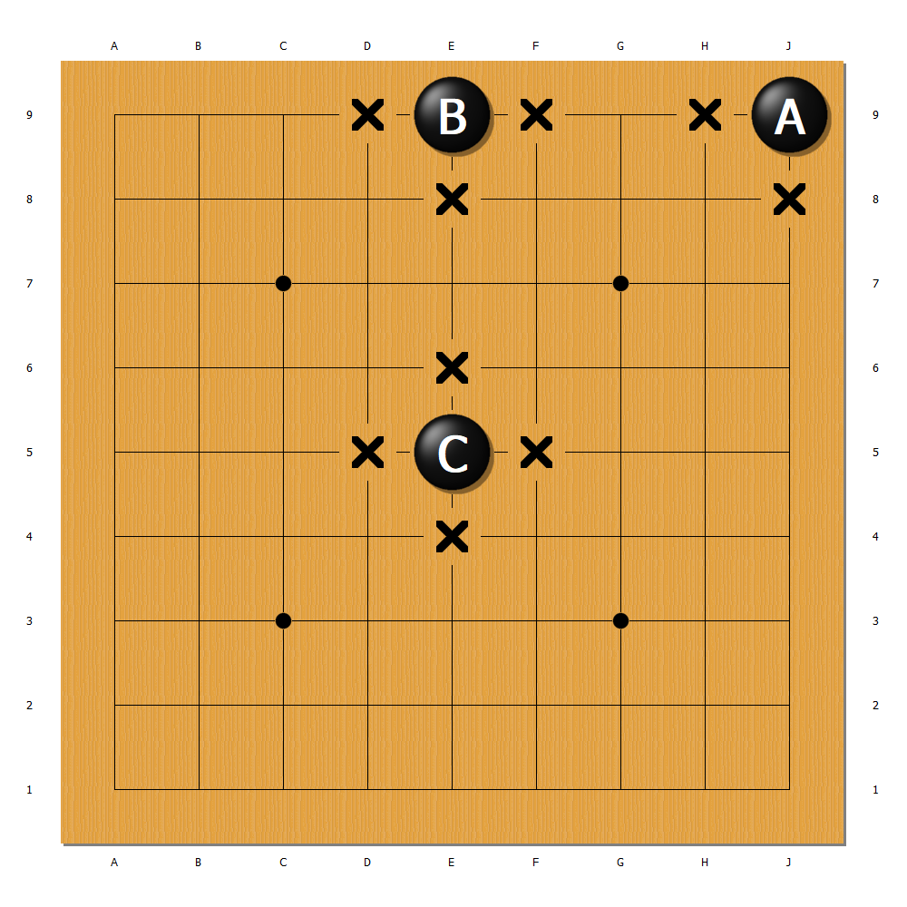

**Figure 11**. One stone can have 2 liberties in the corner (A), 3 liberties on the side (B), and 4 liberties in the middle (C).

We can see that the boundaries of the board eliminate some liberty, so **normally we should’t play on the edge at the beginning**. Now what about 2 connected stones? The answer is integers from 3 to 6 (as shown in Figure 12).

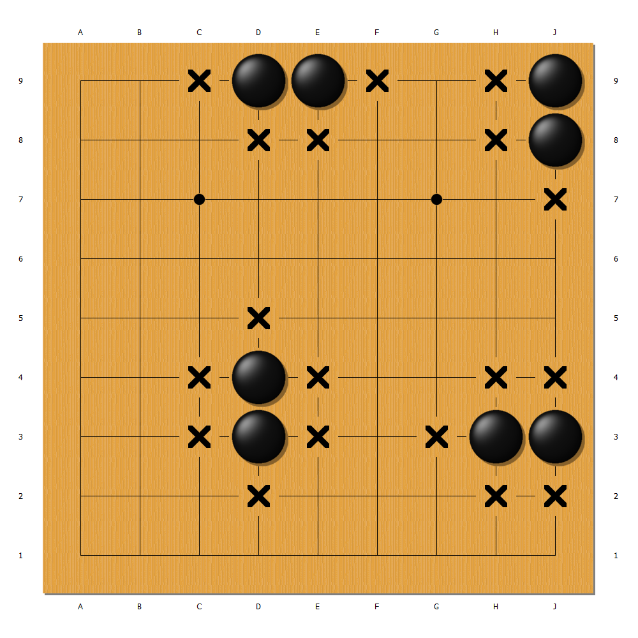

**Figure 12**. Two stone can have liberties from 3 to 6.

When there are more than 2 stones, even if they are all in the middle, the shape of the stones can affect the liberties they have. Therefore we need to pay attention to the shapes of the stones. The good shapes are normally those that give stones more liberties.

Figure 13 shows some good shapes (on the left) and some bad shapes (on the right). You can compare their liberties, and as a beginner, try to avoid those bad shapes.

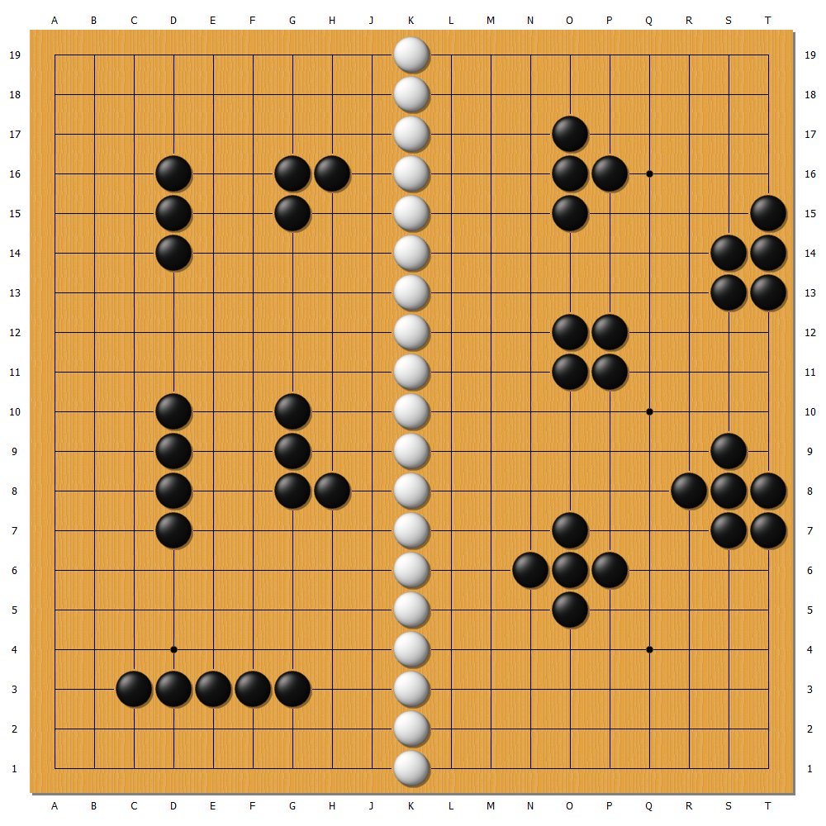

**Figure 13**. Good shapes (left) and bad shapes (right).

Again, we leave the conclusions for our readers to prove on their own:

**(a) With 4 stones in the middle, the range of liberties is 8~10.**

**(b) With 5 stones in the middle, the range of liberties is 8~12.**

**Suggestions for Beginners**

**1. Play on a 9x9 board.** It makes games faster and easier.

**2. Play OGS bot games.** On OGS, click “Play” and then click “Computers”. There are different levels of bots available for you to play. The amybot only plays 9x9 and is normally weaker than 25 kyu, so there’s always one bot for you.

3. **Try to kill as many stones as you can; do not care about the results of the game.** Capture as many stones as you might. It just makes things easier for you, because you do not need to worry about counting points or stones. If you have friends who are also beginners, you can invite them to play games that are intended to kill – for instance, the first person to kill 5 stones wins! That could be so fun! No worry about points; just start a fight!